This is written so that:
- ✅ Freshers / non-technical can understand
- ✅ Developers / AI engineers can build real systems
- ✅ Trainers (like you) can teach + demo + deploy

1️⃣ Where to Find Open-Source LLMs (Official & Trusted)

🔹 Primary Hub (Most Important)

Hugging Face 🤗
👉 https://huggingface.co/models
You’ll find official, verified releases of all major open-source LLMs.
Model Family | Official Org | Popular Models
LLaMA | meta-llama | LLaMA-2, LLaMA-3
Mistral | mistralai | Mistral-7B, Mixtral-8x7B
Falcon | tiiuae | Falcon-7B, Falcon-40B
Qwen (Quen) | Qwen | Qwen-7B, Qwen-14B
Phi | microsoft | Phi-2, Phi-3
Gemma | google | Gemma-2B, 7B
💡 Always prefer models marked:
- ✔️ license: apache-2.0 / mit
- ✔️ verified
- ✔️ instruct / chat variants

2️⃣ Which Model Is Best for Real Business Use?

✅ Recommended (2025, Production-Ready)
Use Case | Best Model
RAG (Docs, PDFs, DB) | Mistral-7B-Instruct
Chatbot / Interview Bot | LLaMA-3-8B-Instruct
Low-resource server | Phi-3 / Qwen-7B
Multi-language business | Qwen-14B
On-prem enterprise | Falcon-7B
⚠️ Avoid training from scratch (costs ₹50L–₹5Cr).
✔️ Fine-tune or use RAG instead.
—

📘 OPEN-SOURCE LLMs

From Basics → Fine-Tuning → RAG → Production Deployment

🌍 1. What is an Open-Source LLM?

📌 Definition (Simple)
An Open-Source Large Language Model (LLM) is a pretrained AI model whose:
- Architecture
- Weights
- Training logic (partially or fully)
are publicly available, allowing customization, fine-tuning, and private deployment.

🧠 Examples of Popular Open-Source LLMs
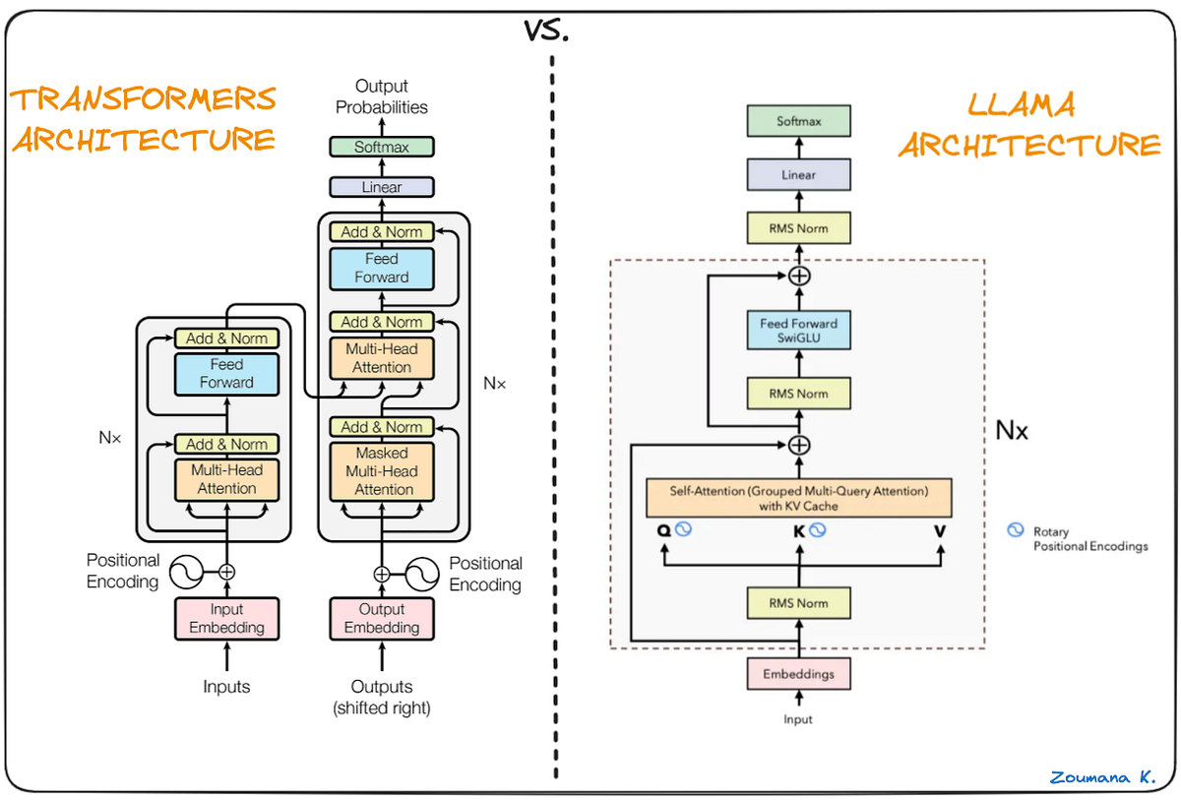
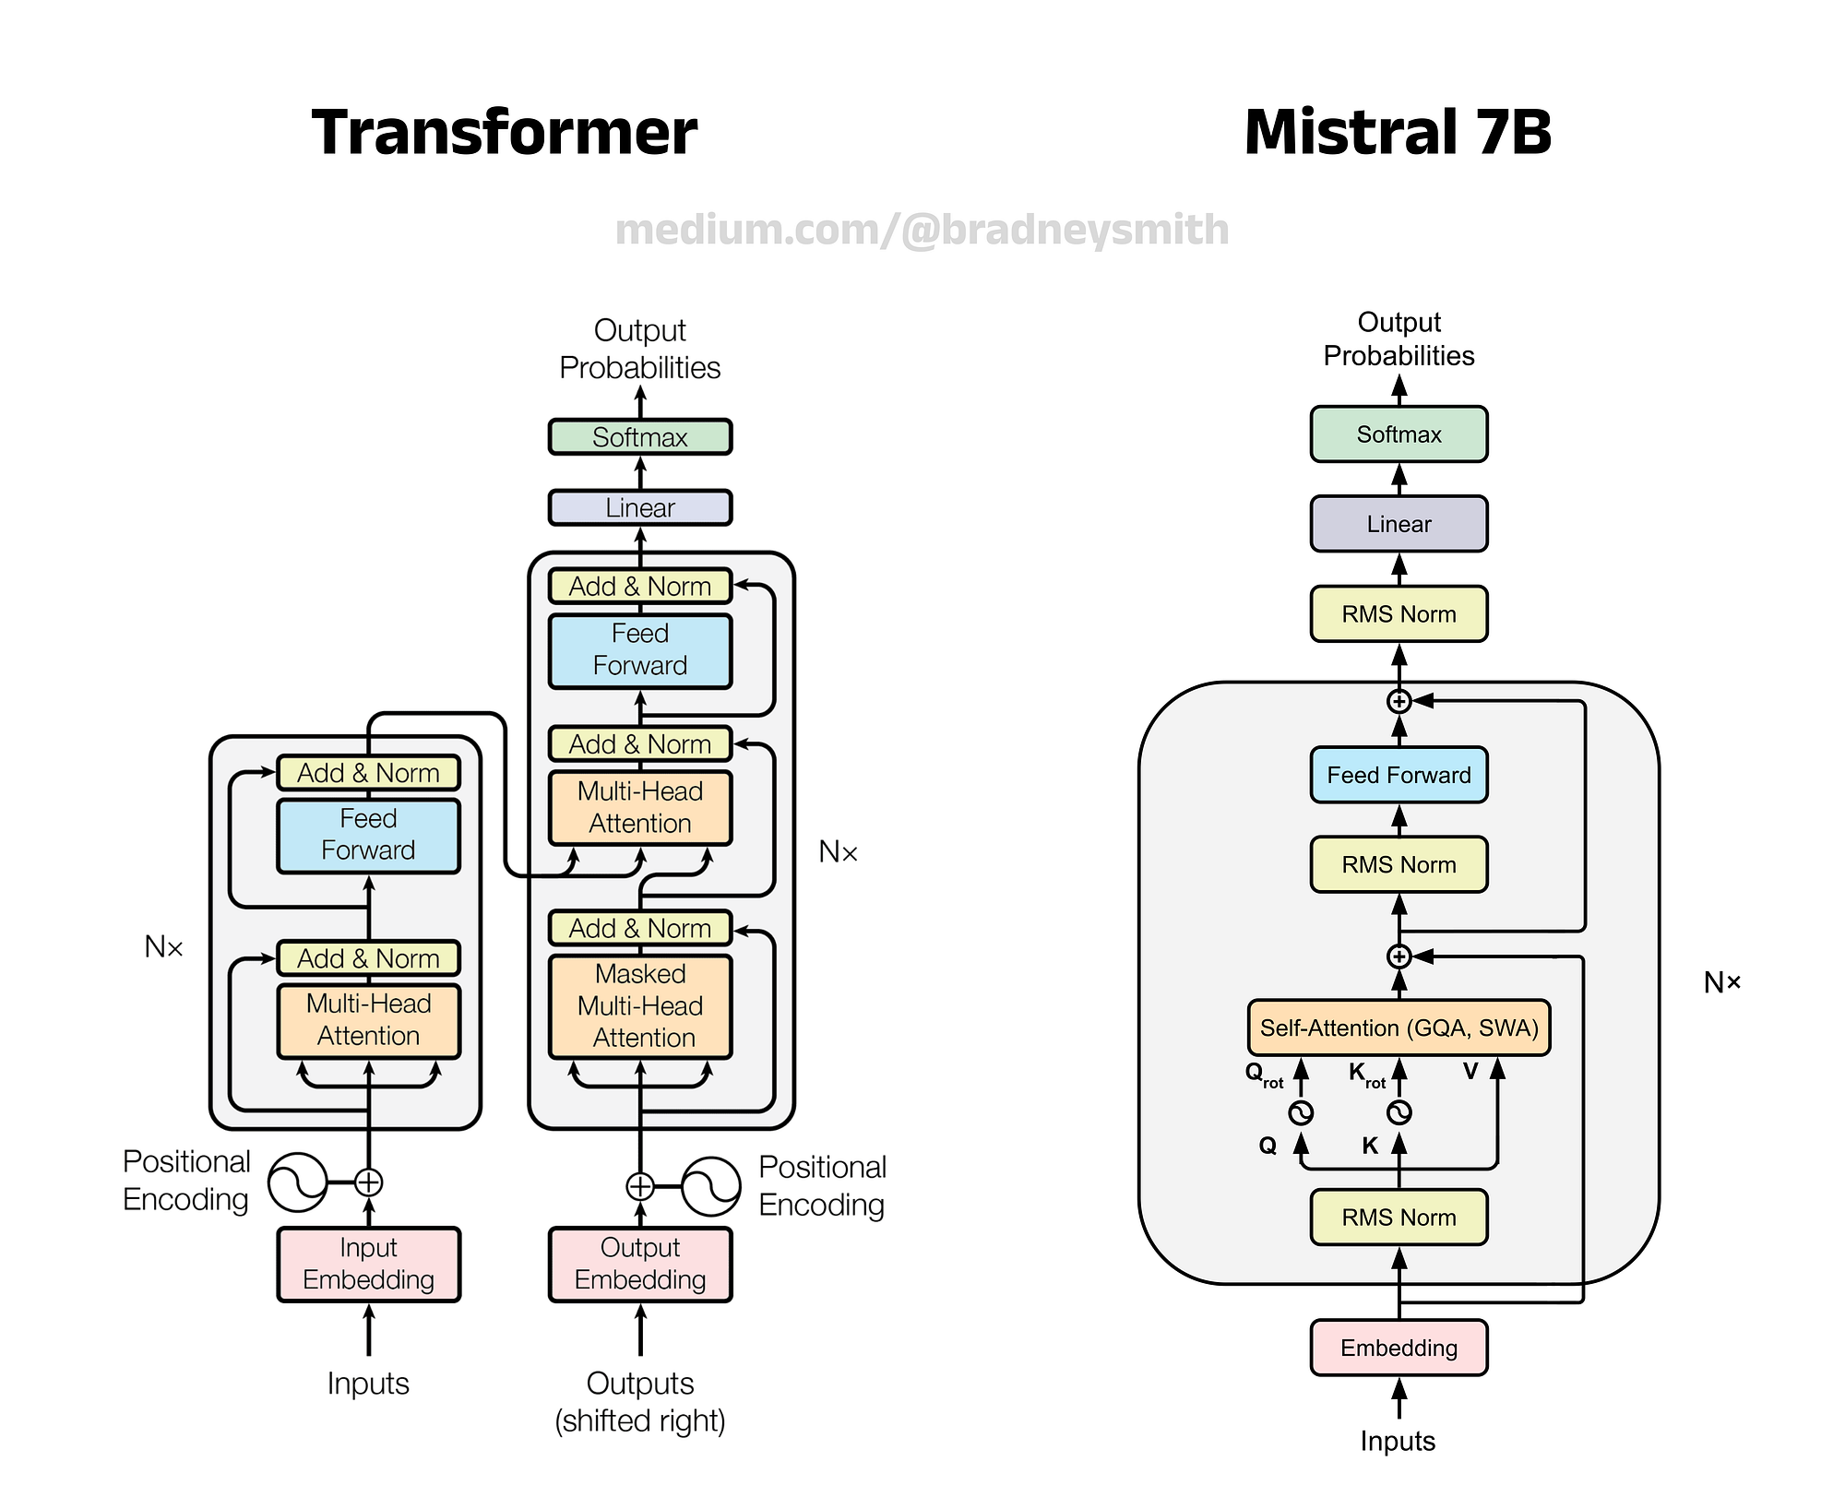
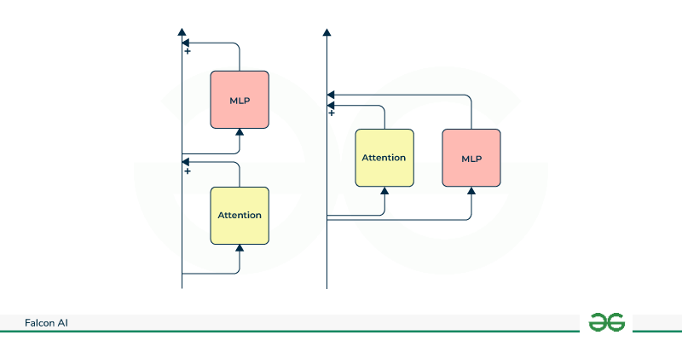
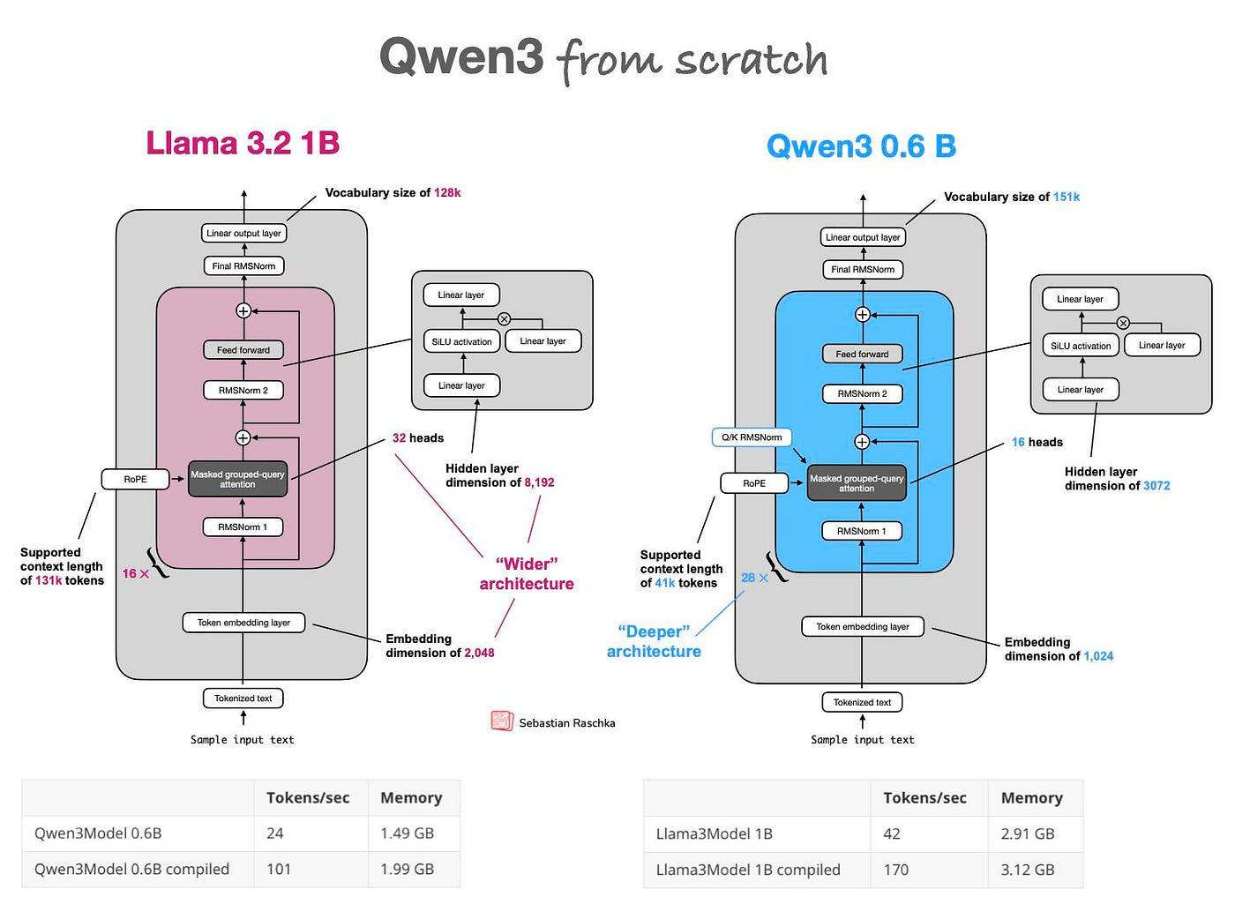
Model | Organization | Strength
LLaMA | Meta | Enterprise-grade
Mistral | Mistral AI | Fast & lightweight
Falcon | TII UAE | Long context
Qwen | Alibaba | Multilingual & agents

🧠 2. Where to Find Open-Source LLMs

🔹 Central Hub (MOST IMPORTANT)

🟢 Hugging Face
You get:
- Models
- Datasets
- Fine-tuning scripts
- Inference APIs
- Deployment tools
📍 Search examples:
meta-llama/*
mistralai/*
tiiuae/*
Qwen/*

🧩 3. Open-Source vs Closed-Source LLMs
Feature | Open-Source | Closed (GPT, Claude)
Model control | ✅ Yes | ❌ No
Fine-tuning | ✅ Yes | ⚠ Limited
Offline use | ✅ Yes | ❌ No
Data privacy | ✅ Full | ❌ External
Cost | Low (infra only) | High (API calls)

🏗️ 4. Core Components of an LLM System
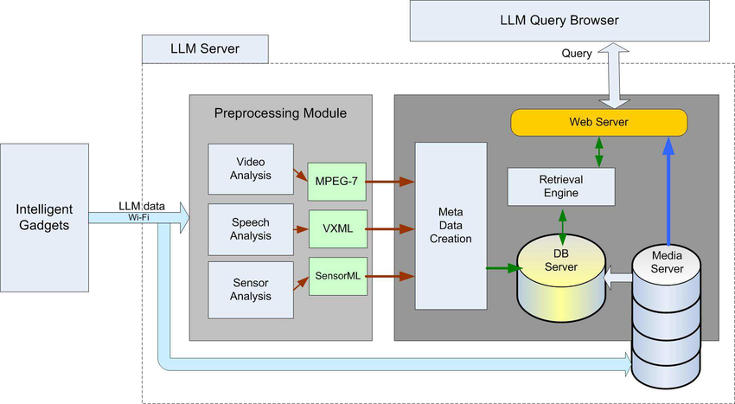
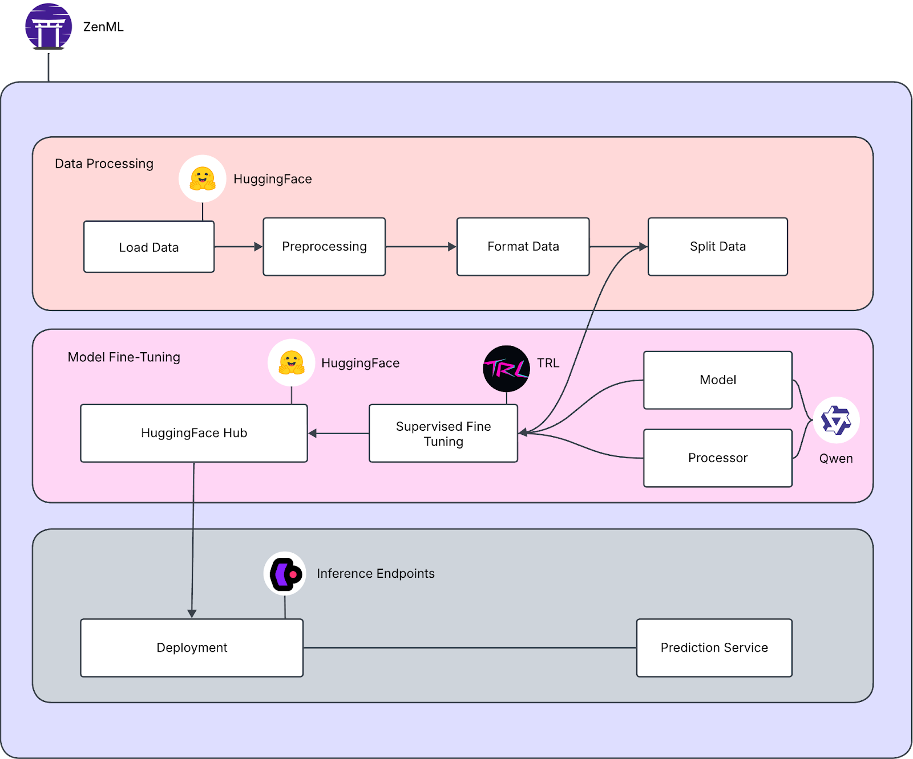

🔹 Components Explained
- Tokenizer
  - Converts text → tokens (numbers)
- Embeddings
  - Tokens → vectors
- Transformer
  - Attention + Feedforward layers
- Decoder
  - Predicts next token

⚙️ 5. Ways to Use Open-Source LLMs in Business

🔥 Method 1: Direct Inference (Beginner)
Prompt → Model → Response

✔ Easy
❌ No company knowledge
Used for:
- Chatbots
- Content generation
- Code assistance

🔥 Method 2: RAG (Recommended for Business)
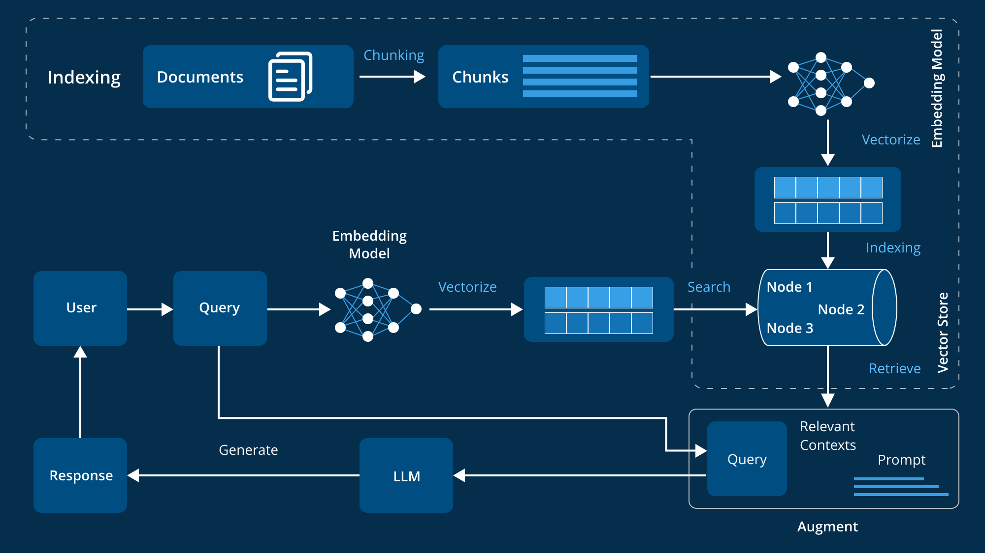
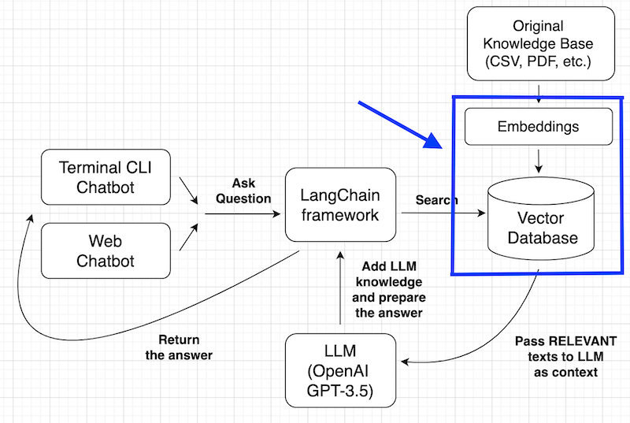
RAG = Retrieval-Augmented Generation
Company Docs
→ Embeddings
→ Vector DB
→ Relevant Chunks
→ LLM

✔ No retraining
✔ Secure
✔ Scalable
✔ Cheapest
Used for:
- HR chatbot
- Legal document QA
- Internal AI tutor
- Support bots

🔥 Method 3: Fine-Tuning (Advanced)
Used when:
- You need custom tone
- Fixed response structure
- Domain-specific language
❌ Full retraining
✅ LoRA / QLoRA

🧪 6. Fine-Tuning Explained (Important)
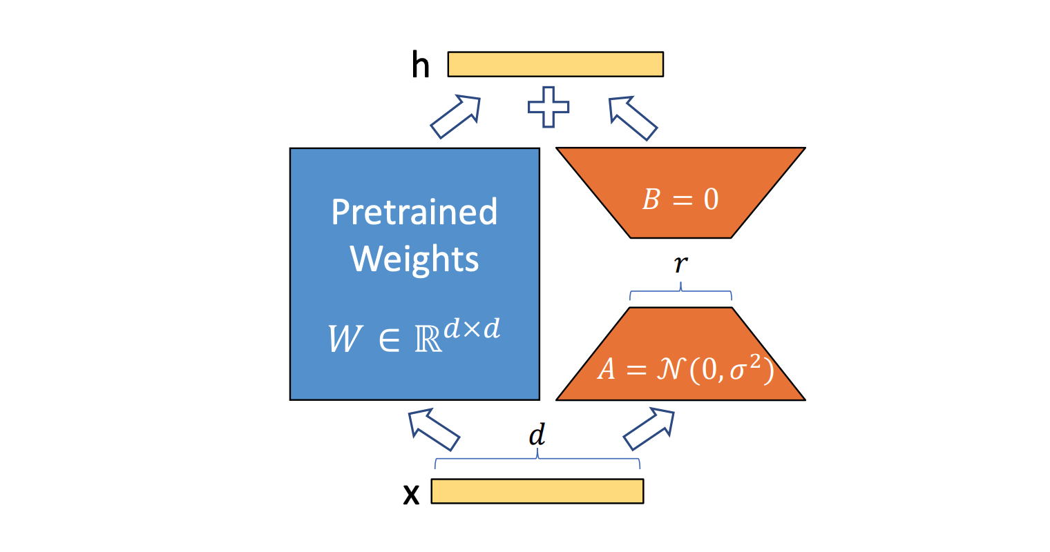
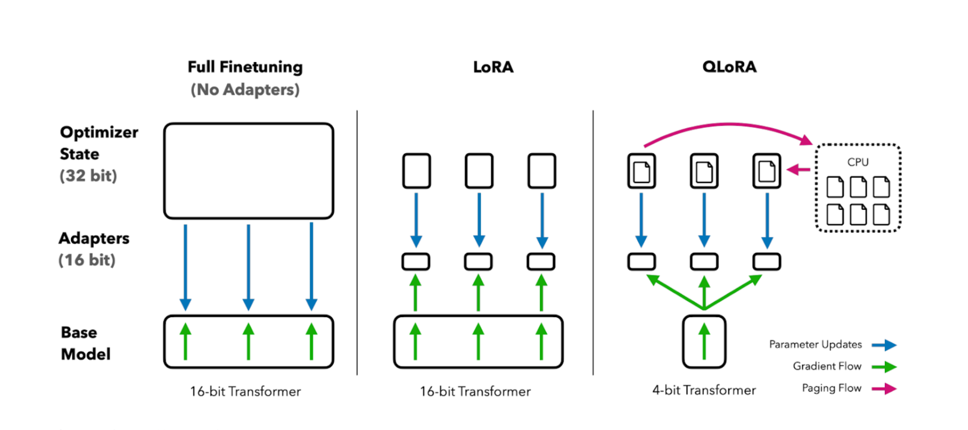
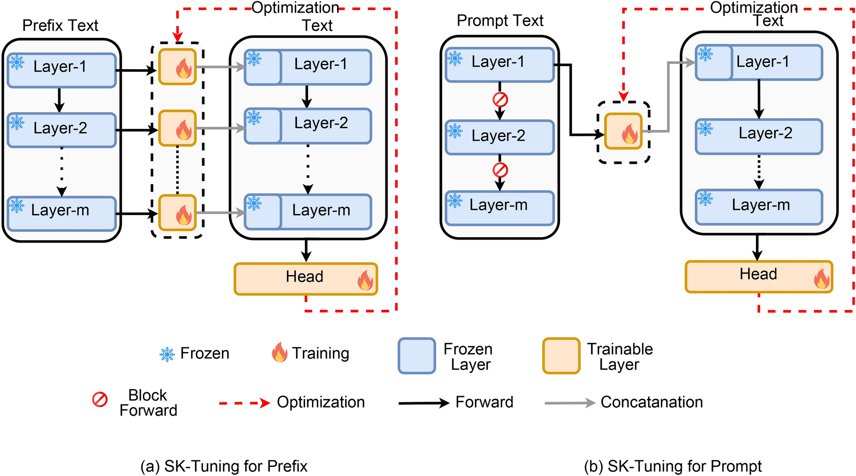

❌ Full Fine-Tuning
- Very expensive
- Needs huge GPUs

✅ LoRA / QLoRA (Industry Standard)
Technique | Advantage
LoRA | Trains only adapters
QLoRA | 4-bit memory saving
Used by:
- Startups
- Enterprises
- Teaching demos

3️⃣ Business-Safe Architecture (IMPORTANT)

❌ Bad Idea
Retrain full LLM with your business data

✅ Correct Business Approach
Your Data → Vector DB (FAISS)
↓
LLM (Frozen)

This is called RAG (Retrieval-Augmented Generation).
✔️ No data leakage
✔️ Fast
✔️ Cheap
✔️ Easy to update
You already plan FAISS → ✔️ Perfect choice

4️⃣ Option 1: Use Model WITHOUT Training (Recommended)

🔹 Run Locally (FREE)

Using Ollama (Best for beginners)
ollama pull mistral
ollama pull llama3
ollama run mistral

Use in Python:
from langchain.llms import Ollama

llm = Ollama(model="mistral")
response = llm("Ask interview question for Python developer")
print(response)

✔️ Works offline
✔️ No API cost
✔️ Business-safe

5️⃣ Option 2: Fine-Tune Model (When You REALLY Need)

🔹 When to Fine-Tune?
✔️ Domain-specific tone
✔️ Fixed response style
✔️ Interview scoring logic
❌ Not for large knowledge

✅ Best Fine-Tuning Method: LoRA / QLoRA

Tools You’ll Use
- 🤗 transformers
- peft
- bitsandbytes

Example (LLaMA / Mistral)
from peft import LoraConfig, get_peft_model
from transformers import AutoModelForCausalLM

model = AutoModelForCausalLM.from_pretrained(
"mistralai/Mistral-7B-Instruct-v0.2",
load_in_4bit=True
)

lora_config = LoraConfig(
r=8,
lora_alpha=32,
target_modules=["q_proj", "v_proj"]
)

model = get_peft_model(model, lora_config)

💻 Hardware Needed
Model | GPU
7B | RTX 3060 (12GB)
13B | RTX 4090
CPU | Very slow (not recommended)

6️⃣ Option 3: RAG (BEST for Business – Highly Recommended)

🔹 Stack You Should Use (Perfect for You)
PDF / Resume / JD
↓
Text Splitter
↓
Embeddings (sentence-transformers)
↓
FAISS Vector DB
↓
LLM (Mistral / LLaMA)

Example (FAISS + LLM)
from langchain.vectorstores import FAISS
from langchain.embeddings import HuggingFaceEmbeddings

emb = HuggingFaceEmbeddings(
model_name="sentence-transformers/all-MiniLM-L6-v2"
)

db = FAISS.from_texts(texts, emb)
docs = db.similarity_search("Python interview questions")

llm("Ask questions based on this: " + docs[0].page_content)

✔️ No retraining
✔️ Update anytime
✔️ Best for real companies

7️⃣ Licensing (VERY IMPORTANT FOR BUSINESS)
Model | Commercial Use
Mistral | ✅ Yes
Falcon | ✅ Yes
Qwen | ✅ Yes
LLaMA 2/3 | ⚠️ Yes (Meta license)
Gemma | ⚠️ Some restrictions
📌 Always check LICENSE file on Hugging Face

8️⃣ Recommended Stack for YOUR Projects
Based on your history (AI Interview App, FAISS, Flask):

✅ Final Recommendation
Frontend: Streamlit / React
Backend: Flask / FastAPI
LLM: Mistral-7B or LLaMA-3
Embeddings: sentence-transformers
Vector DB: FAISS
Auth: JWT
Deployment: Docker + AWS EC2

🛠️ 7. Tools You MUST Learn
Purpose | Tool
Model loading | transformers
Fine-tuning | peft
Training | accelerate
RAG | LangChain
Vector DB | FAISS / Chroma
API | FastAPI
UI | Streamlit / Gradio
Deployment | Docker

🖥️ 8. Hardware Requirements (Realistic)
Model | GPU
Mistral-7B | RTX 3060 (12GB)
LLaMA-7B | RTX 3090
Qwen-14B | A100
CPU only | Small models / Ollama
💡 Tip: 4-bit quantization saves 70% memory

🚀 9. Production-Level Architecture
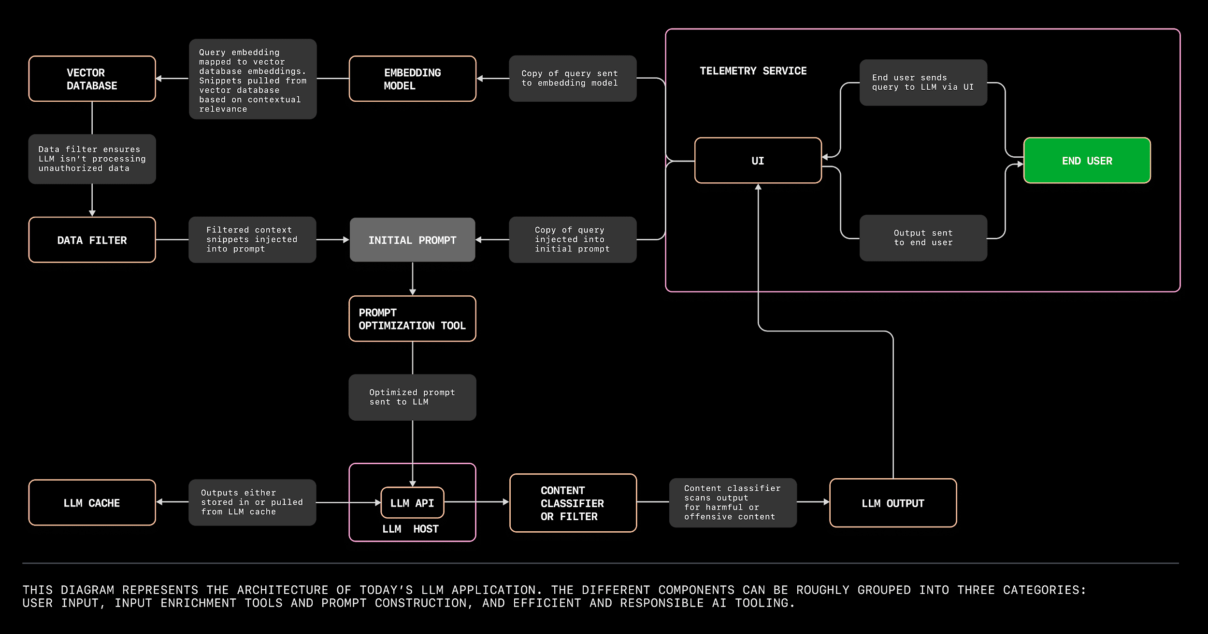
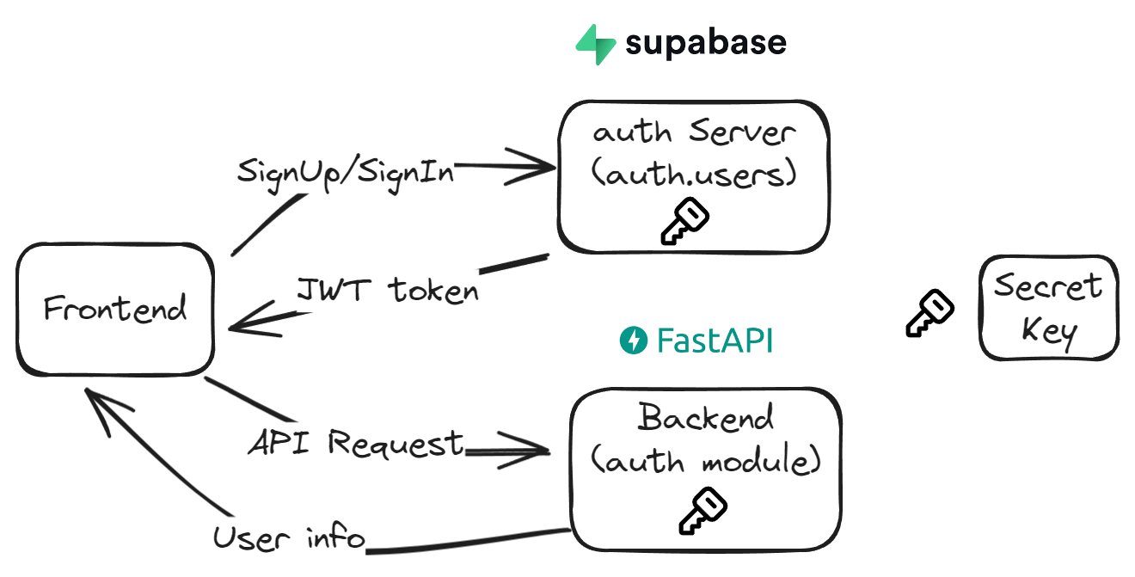
Frontend (Web / Mobile)
↓
FastAPI Backend
↓
RAG / Fine-Tuned LLM
↓
Vector DB (FAISS)
↓
Private Company Data

🔐 10. Security & Privacy (Very Important)
✔ On-premise deployment
✔ No data sent to third-party
✔ Role-based access
✔ Logs & monitoring
Open-source = FULL CONTROL

📊 11. Real Business Use Cases
Industry | Solution
Education | AI Tutor
HR | Resume Analyzer
Legal | Contract QA
Healthcare | Report Summarizer
IT | Internal Knowledge Bot
Govt | Policy Assistant

📦 12. Deployment Options
Method | Use Case
Docker | Production
Ollama | Offline
Hugging Face Spaces | Demo
Cloud VM | Scaling

🧭 13. Learning Path (Recommended)

🔹 Beginner
- Prompting
- Inference
- Hugging Face

🔹 Intermediate
- RAG
- Vector DB
- LangChain

🔹 Advanced
- LoRA fine-tuning
- Quantization
- CI/CD

🎯 14. Final Recommendation for You (Teacher + Builder)
Based on your background:
- Data Science
- AI Teaching
- Production projects

✅ Best Stack
Mistral-7B
+ RAG
+ FAISS
+ FastAPI
+ Docker

🚀 What I Can Build Next for You
1️⃣ PDF teaching notes
2️⃣ End-to-end RAG project (code + UI)
3️⃣ LoRA fine-tuning notebook
4️⃣ Offline private LLM using Ollama
5️⃣ Production deployment on GCP/AWS
Just tell me what you want first — I’ll build it step-by-step for you 👨‍🏫🔥

🔹 Business-Ready Examples
Business | Model
Resume Analyzer | Mistral + RAG
HR Chatbot | LLaMA + FAISS
Legal Doc QA | Falcon
Multilingual Support | Qwen
Internal AI Tutor | LLaMA / Mistral

